

Modern Excel Analyst in a Day

Lab 02A

Mapping Learning to Power BI – Import to Power BI Desktop

# Overview

The estimated time to complete this lab is 20 minutes.

In this lab, you will complete the following tasks:

1. Import from Excel to Power BI Desktop: Customers & Quotes queries & tables
2. Edit imported Queries to Include a Dates table
3. Close Power Query & Load the Dates table to the Data Model

**NOTE:** This lab has been created based on the sales activities of the *fictitious* Wi-Fi company called SureWi which has been provided by P3 Adaptive <https://p3adaptive.com/>. The data is property of P3 Adaptive and has been shared with the purpose of demonstrating Excel and Power BI functionality with industry sample data. Any use of this data must include this attribution to P3 Adaptive.

Exercise 1: Import from Excel to Power BI Desktop: Customers & Quotes queries and tables

In this exercise, you will launch Power BI Desktop and import the Customers & Quotes queries and tables from Excel to Power BI Desktop.

### Task 1: Launch Power BI Desktop

In this task, you will launch Power BI Desktop and save the new PBIX file.

1. Launch Power BI Desktop.



1. If applicable, use the “x” in the upper right-hand corner to close the Welcome window.

### Task 2: Verify Settings

1. In the Main power BI Ribbon, navigation to File > Options and settings > Options.
2. In the Global section, select Data Load and in the Type Detection section, validate the radio button option for Detect column type and headers for unstructured sources according to each file’s settings is selected.

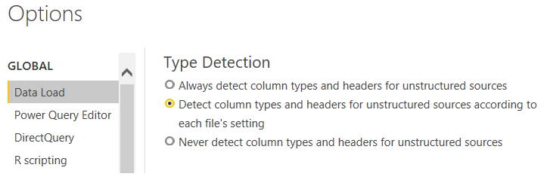

### Task 3: Import Power Query, Power Pivot, Power View

In this task, you will navigate and open the starting XLSX file then start the import process.

1. Select File > Import > Power Query, Power Pivot, Power View

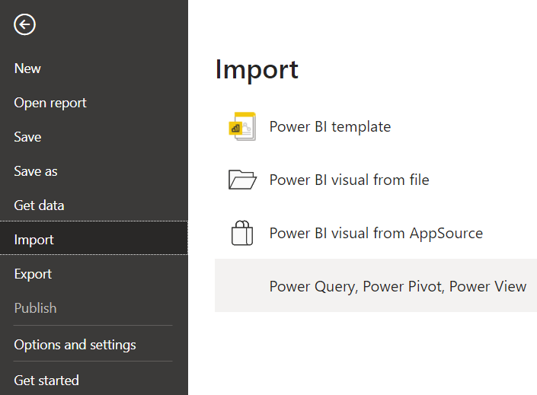

1. Navigate to the <CourseFolder>\**Attendee\Lab Materials\Lab 02A**\ folder.
2. Select the file **“**MAIAD Lab 02A – Start.xlsx” and choose Open.

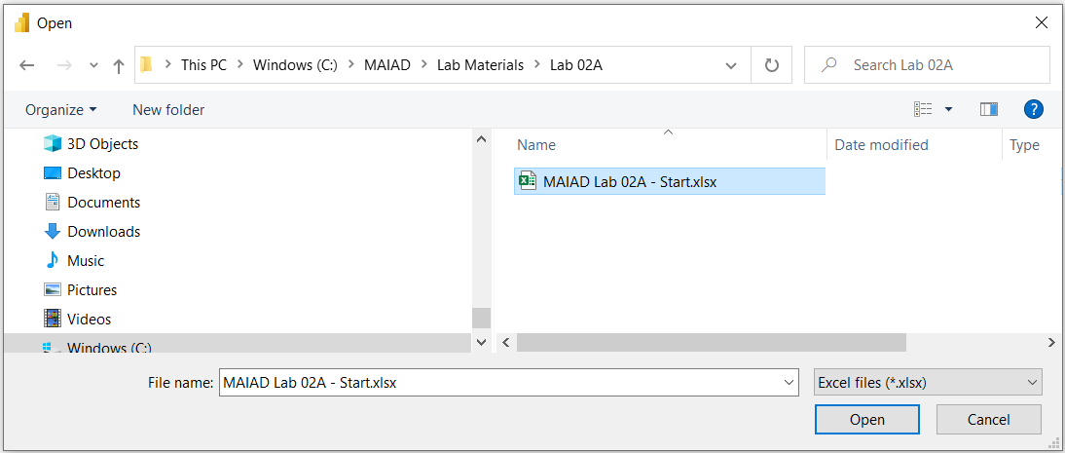

1. Select the Start button to begin the import.
2. View the Import Excel workbook contents report.
3. Then select the Close button.

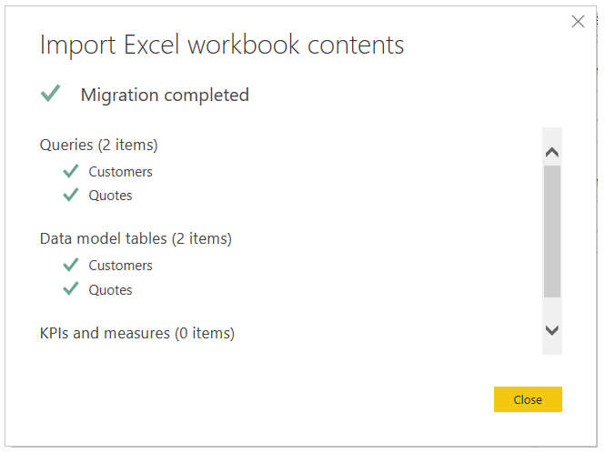

Note: When importing from Excel to Power BI Desktop, it is a one-way transition. Any Queries, Data Model tables, KPIs and measures will be imported into Power BI Desktop. Any subsequent imports with the same file name will overwrite the existing PBIX.

1. Notice that the Customers and Quotes tables are available in the Fields list.

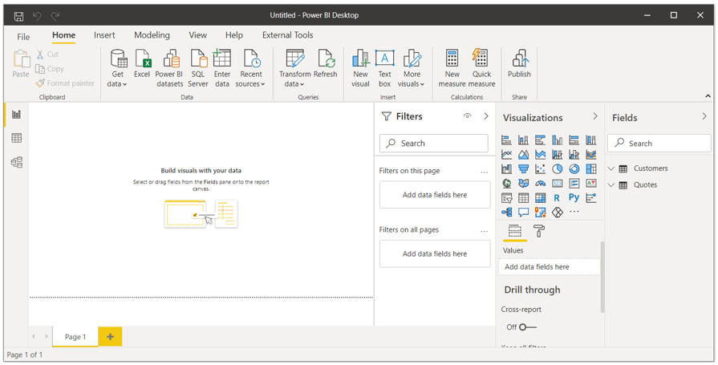

### Task 4: Save the PBIX file

In this task, you will save the file with a new file name.

1. Select File > Save as.

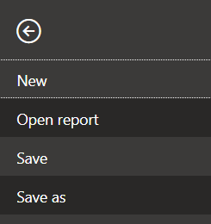

1. Save the file as “**MAIAD Lab 02A – Power BI Import – My Solution.pbix**”.

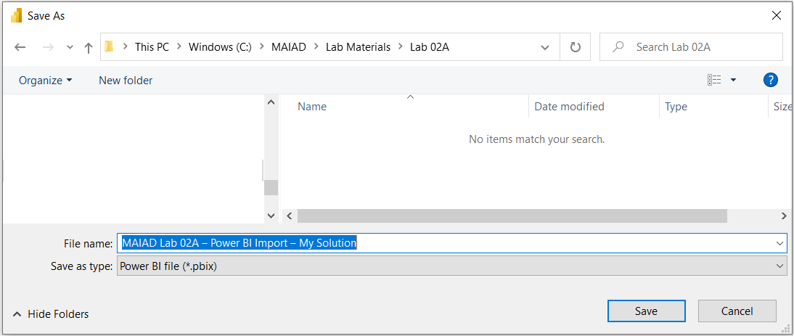

Exercise 2: Edit imported Queries to Include a Dates table

In this exercise, you will launch the Power Query Editor from BI Desktop and edit the imported Queries to add a new Dates query and table to the Data Model.

### Task 1: Launch Power Query from Power BI Desktop

In this task, you will launch Power Query from Power BI Desktop and edit the existing queries to add a new Dates table.

1. From the Home ribbon, select Transform data > Transform data option.

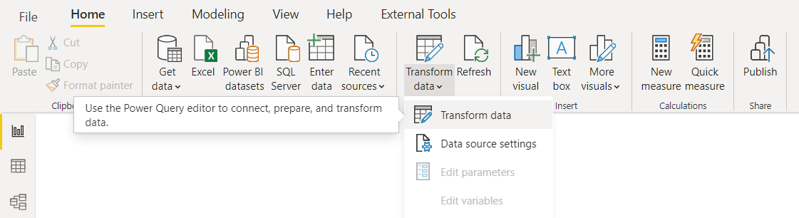

Note: This will launch Power Query from Power BI Desktop – notice it looks very similar to Power Query in Excel and both the Customers and Quotes queries have been imported with their transformation.

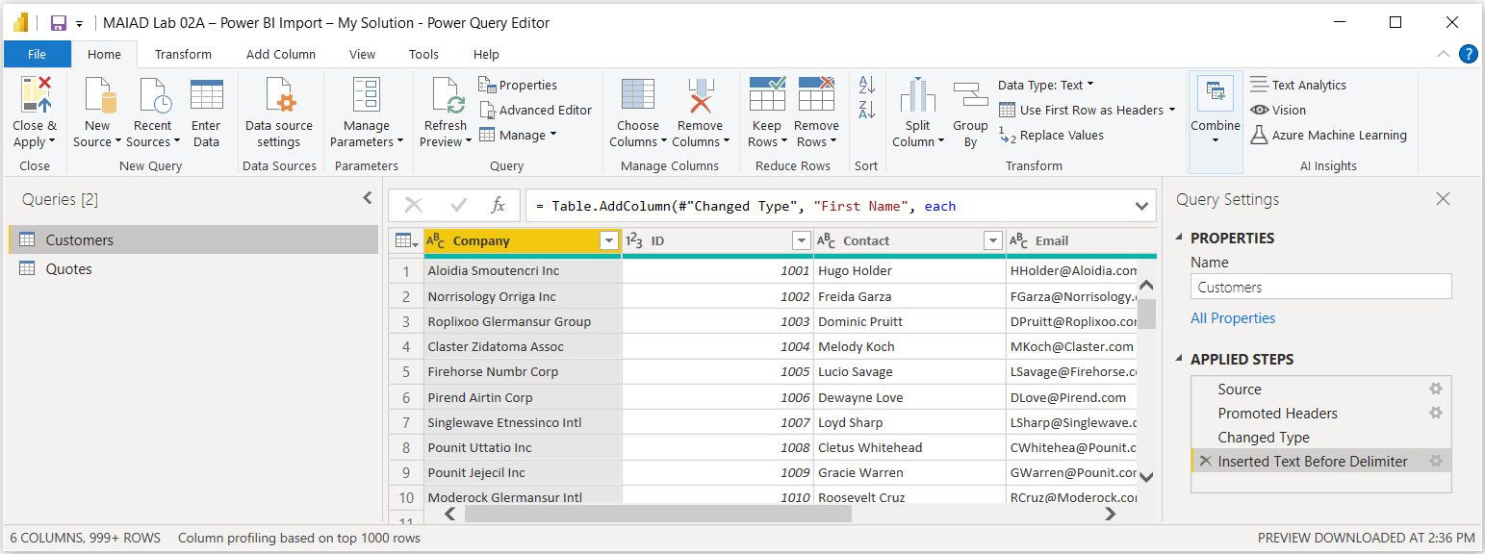

### Task 2: New Source – Add a Dates table

In this task, you will add a Dates table to the existing Queries and Load the new query and table to the Data Model.

1. From the Power Query Editor Home ribbon, select New Source > Text/CSV option.

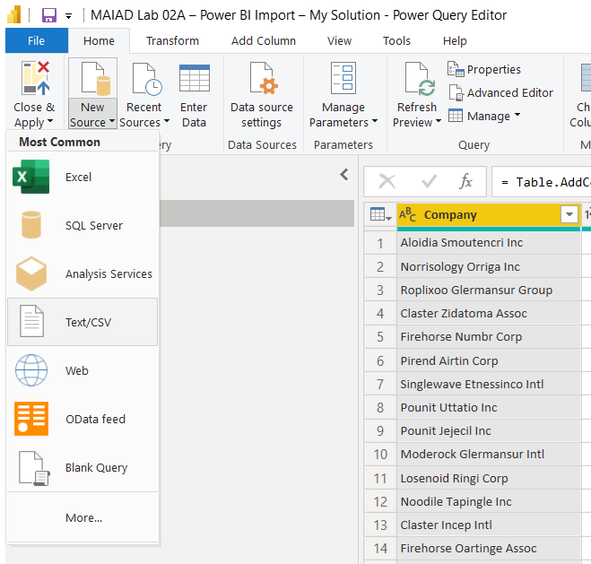

1. Navigate to the <CourseFolder>\**Attendee\Lab Materials\Lab 02A**\ folder.
2. Select the file **“**MAIAD Lab 02A - Data Source – Dates.csv” and choose Open.

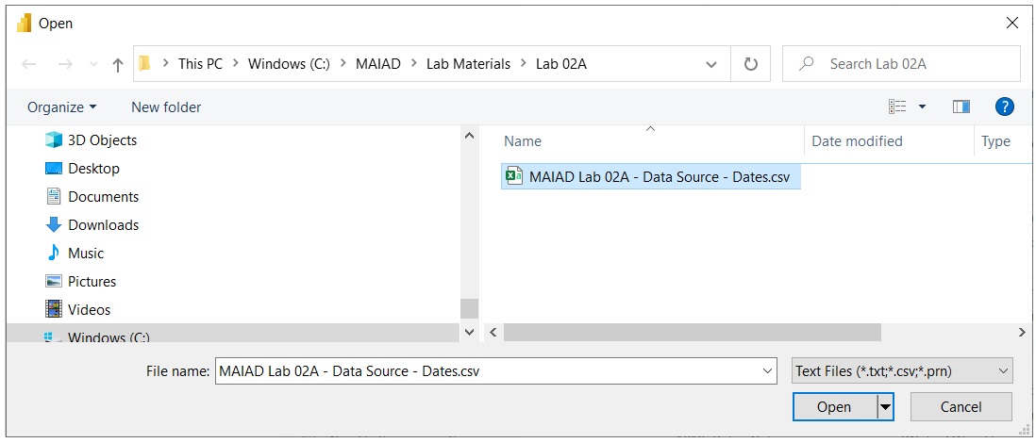

1. Accept the default File Origin, Delimiter, and Data Type Detection options. Then select the OK button.

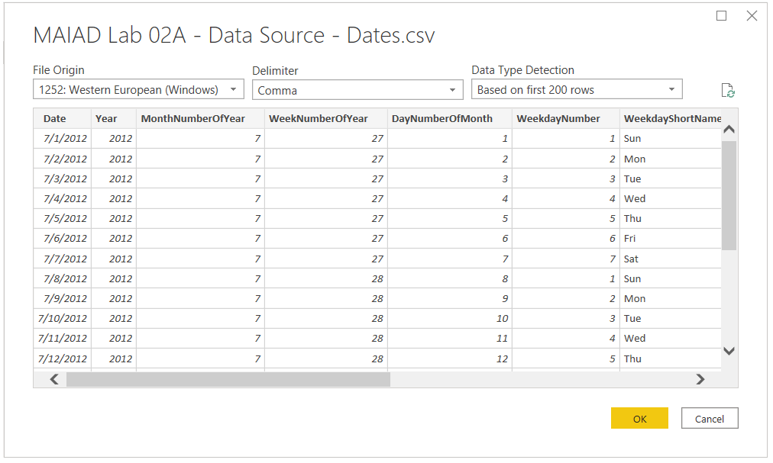

### Task 3: Rename Query

In this task, you will add a rename the Query to use a user-friendly noun name versus the default file name.

1. Double-click in the Queries Pane on “MAIAD Lab 02A – Data Source – Dates” to rename the default Query name.

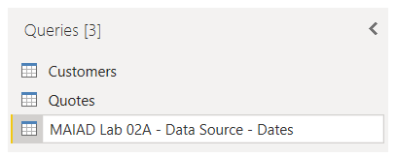

1. Rename from “MAIAD Lab 02A – Data Source – Dates” to just “Dates”.

### Task 4: Perform a Data Type Transformation

In this task, you will add a change the default data type for the [Year] column of the #”Dates” query.

1. In the Preview area, click on the “123” data type icon of the [Year] column and change the data type from a Whole Number to Text.

Note: Column data types drive different functionality in Power BI – for example, a Whole Number will default to aggregate. It would not make sense that we would ever SUM the [Year] column so by changing to a Text data type, we prevent this default aggregation in Power BI.

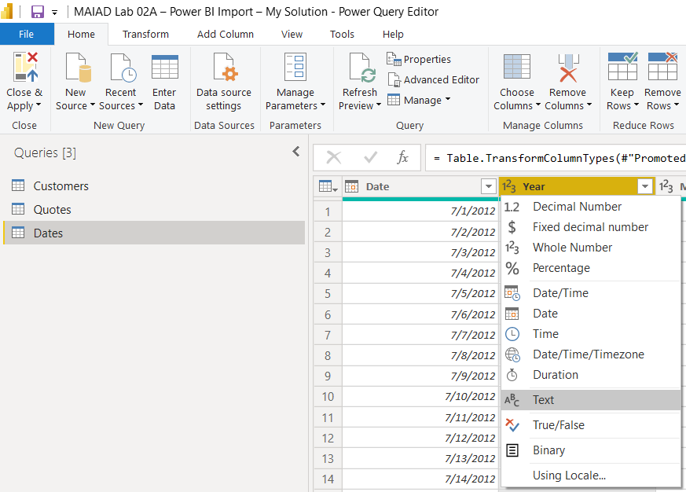

1. Select the Replace current button from the Change Column Type window.

Note: Since we are on the Change Type in the Applied Steps, this message confirms that we want to change the [Year] to the Text data type in this existing step. The Add new step would change the [Year] to the Text data type but add as a NEW step in the Applied Steps.

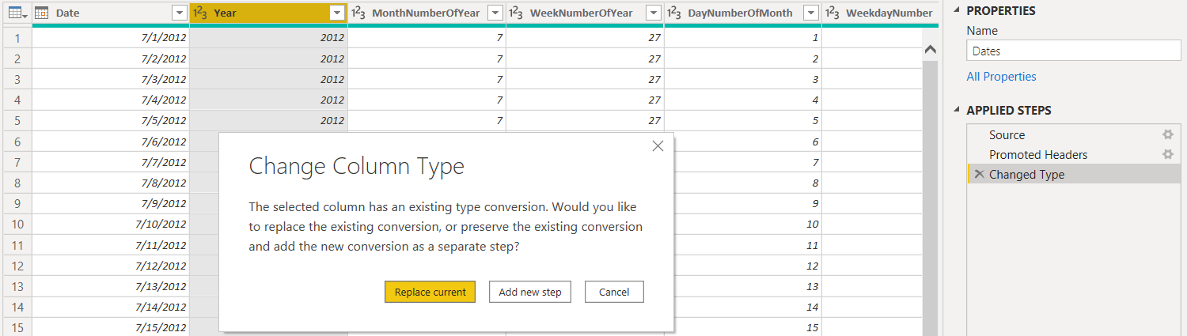

Exercise 3: Close Power Query & Load Dates table to the Data Model

In this exercise, you will Close & Apply the Power Query Editor changes and Load the Dates table to the Data Model.

### Task 1: Close & Apply

In this task, you will use the Close & Apply button to save the Dates query in the Power Query Editor and Load the Dates table to the Data Model.

1. From the Power Query Editor Home ribbon, select Close & Apply button > Close & Apply option to load the new Dates table to the Data Model.

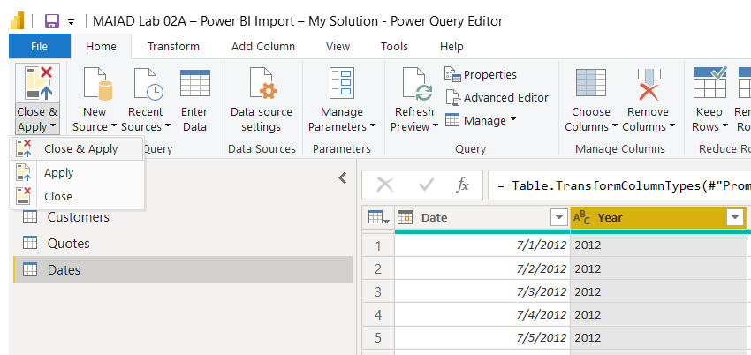

### Task 2: View the Dates table in the Fields list

In this task, you will observe that the new Dates table is now also available in the Fields list.

1. From the Fields list, notice the new Dates table is now available.

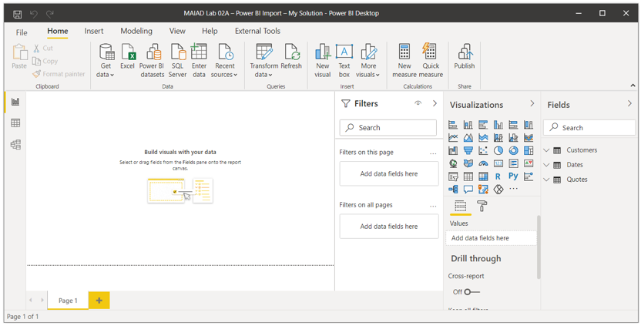

# Summary

In this lab, you started with an existing Excel file that contained Power Query data connections to an Excel and CSV file from the previous Lab. You launched the Power BI Desktop application and imported the existing Power Connections from Excel to Power BI Desktop and saved as a PBIX file. Then you used the Transform data button to launch the Power Query Editor from within Power BI Desktop to load a new Dates query from a CSV data source and used the Preview area to perform a data type transformation of the [Year] column. Lastly, you used the Closed & Apply option to add the Dates query as a new table to the Data Model.

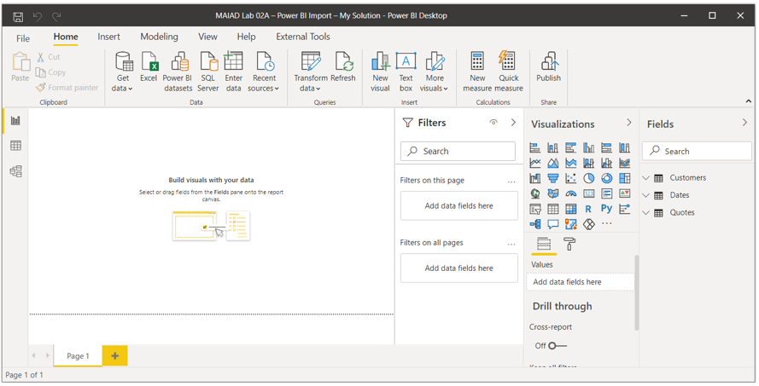

# Terms of Use

© 2021 Microsoft. All rights reserved.

By using this hands-on lab, you agree to the following terms:

The technology/functionality described in this hands-on lab is provided by Microsoft Corporation in a “sandbox” testing environment for purposes of obtaining your feedback and to provide you with a learning experience. You may only use the hands-on lab to evaluate such technology features and functionality and provide feedback to Microsoft. You may not use it for any other purpose. Without written permission, you may not modify, copy, distribute, transmit, display, perform, reproduce, publish, license, create derivative works from, transfer, or sell this hands-on lab or any portion thereof.

COPYING OR REPRODUCTION OF THE HANDS-ON LAB (OR ANY PORTION OF IT) TO ANY OTHER SERVER OR LOCATION FOR FURTHER REPRODUCTION OR REDISTRIBUTION WITHOUT WRITTEN PERMISSION IS EXPRESSLY PROHIBITED.

THIS HANDS-ON LAB PROVIDES CERTAIN SOFTWARE TECHNOLOGY/PRODUCT FEATURES AND FUNCTIONALITY, INCLUDING POTENTIAL NEW FEATURES AND CONCEPTS, IN A SIMULATED ENVIRONMENT WITHOUT COMPLEX SET-UP OR INSTALLATION FOR THE PURPOSE DESCRIBED ABOVE. THE TECHNOLOGY/CONCEPTS REPRESENTED IN THIS HANDS-ON LAB MAY NOT REPRESENT FULL FEATURE FUNCTIONALITY AND MAY NOT WORK THE WAY A FINAL VERSION MAY WORK. WE ALSO MAY NOT RELEASE A FINAL VERSION OF SUCH FEATURES OR CONCEPTS. YOUR EXPERIENCE WITH USING SUCH FEATURES AND FUNCITONALITY IN A PHYSICAL ENVIRONMENT MAY ALSO BE DIFFERENT.

FEEDBACK If you give feedback about the technology features, functionality and/or concepts described in this hands-on lab to Microsoft, you give to Microsoft, without charge, the right to use, share and commercialize your feedback in any way and for any purpose. You also give to third parties, without charge, any patent rights needed for their products, technologies and services to use or interface with any specific parts of a Microsoft software or service that includes the feedback. You will not give feedback that is subject to a license that requires Microsoft to license its software or documentation to third parties because we include your feedback in them. These rights survive this agreement.

MICROSOFT CORPORATION HEREBY DISCLAIMS ALL WARRANTIES AND CONDITIONS WITH REGARD TO THE HANDS-ON LAB, INCLUDING ALL WARRANTIES AND CONDITIONS OF MERCHANTABILITY, WHETHER EXPRESS, IMPLIED OR STATUTORY, FITNESS FOR A PARTICULAR PURPOSE, TITLE AND NON-INFRINGEMENT. MICROSOFT DOES NOT MAKE ANY ASSURANCES OR REPRESENTATIONS WITH REGARD TO THE ACCURACY OF THE RESULTS, OUTPUT THAT DERIVES FROM USE OF THE VIRTUAL LAB, OR SUITABILITY OF THE INFORMATION CONTAINED IN THE VIRTUAL LAB FOR ANY PURPOSE.

DISCLAIMER This lab contains only a portion of new features and enhancements in Microsoft Power BI. Some of the features might change in future releases of the product.